EVALUATION RUBRIC FOR PRELIMINARY PROPOSAL – PRODUCT PROJECTS
Faculty advisors: Please complete this rubric and return it, with the graded report, to 102 DB by 4:30PM on Nov. 8
Project Name: _________________________________ Grader Name:______________________
A+ | 100% | Truly outstanding technical work and writing. Difficult to imagine anything better by faculty.
A | 95% | Excellent. Substantial insight, originality, creativity, competence. Fully developed and detailed
B | 85% | Strong. Thorough. Shows good understanding, competence. Well developed, w/ supporting detail
C | 75% | Adequate. Demonstrates adequate understanding, competence. Adequately development, detail.
D | 65% | Weak. Shows some understanding and/or competence. Undeveloped or lacking supporting detail
F | 55% | Unsatisfactory. Demonstrates some effort, but little understanding or competence. Undeveloped
F- | 0% | Unacceptable. Completely omitted, or demonstrates very, very little effort.

CATEGORY  (grade weight) | DESCRIPTION | GRADE  (A-F)
BACKGROUND  Chapter 1  Section 1.1  (5%) | A general description of the project: what is to be accomplished, relevance / significance to the sponsor, and benefits upon completion.
EXISTING DESIGNS, DEVICES, AND METHODS:  SYSTEM LEVEL  Chapter 2  Section 2.1  (5%) | A description of at least 3 relevant existing designs, devices, and methods related to the project topic at the system, or entire entity, level (e.g. if the project were to design a car, descriptions of other vehicles would be given)
EXISTING DESIGNS, DEVICES, AND METHODS:  COMPONENT LEVEL  Chapter 2  Section 2.2  (5%) | A functional decomposition of the project topic into its primary components. For each component, a description of at least 3 relevant existing designs, devices, and methods (e.g. if designing a car, describe steering, braking etc)
DESIGNS CONSIDERED  Chapter 3  All Sections  (20%) | Descriptions of at least three complete and distinctly different designs (including all components listed in section 2.2). Advantages and disadvantages given for each.
DESIGN SELECTED  Chapter 4  Section 4.1  (20%) | Selection and justification, using technical analysis, of one design option from those presented in Chapter 3. Explanation given of how this design meets all requirements.
CLARITY & CONCISENESS  (15%) | Absence of “padding” and unnecessary repetition. Clarity, conciseness and focus..
ORGANIZATION  (15%) | Proper sequencing, paragraph breaks, and flow of ideas. Transitions among sentences, paragraphs, and ideas. Details fit where placed
CONVENTIONS  Graded By Course Instructor  (10%) | Proper use of writing conventions (punctuation, spelling, capitalization, grammar, and usage).
CITING SOURCES  (5%) | Claims substantiated by correct citations in text and references in bibliography
Note: Section 1.2, Requirements, graded by the course instructor.

OSU Mini Malter
Preliminary Proposal

Curtis Barnard
Tyler Froemming
Aaron Mason

2010/11

Project Sponsor: OSU Department of Food Science and Technology
ME 497/498
Project Number: 73
Faculty Advisor: Joe Hortnagl
Sponsor Mentor: Jeff Clawson, Tom Shellhammer
DISCLAIMER
This report was prepared by students as part of a college course requirement. While considerable effort has been put into the project, it is not the work of a licensed engineer and has not undergone the extensive verification that is common in the profession. The information, data, conclusions, and content of this report should not be relied on or utilized without thorough, independent testing and verification. University faculty members may have been associated with this project as advisors, sponsors, or course instructors, but as such they are not responsible for the accuracy of results or conclusions.

TABLE OF CONTENTS
PROJECT DESCRIPTION 5
PROJECT DESCRIPTION 5
1.1. Background 5
1.2. Requirements 5
1.2.1. Project Description 5
1.2.2. Customer Requirements (CRs) 5
1.2.3. Engineering Requirements (ERs) 7
1.2.4. House of Quality (HoQ) 9
2. EXISTING DESIGNS, DEVICES, AND METHODS 10
2.1. System Level 10
2.1.1. Design, Device, or Method #1 10
2.1.2. Design, Device, or Method #2 10
2.1.3. Design, Device, or Method #3 11
2.1.4. Design, Device, or Method #4 11
2.2. Component Level 11
2.2.1. Component #1 12
2.2.1.1. Design, Device or Method #1 12
2.2.1.2. Design, Device or Method #2 12
2.2.1.3. Design, Device or Method #3 12
2.2.2. Component #2 12
2.2.2.1. Design, Device or Method #1 12
2.2.2.2. Design, Device or Method #2 12
2.2.2.3. Design, Device or Method #3 13
2.2.2.4. Design, Device or Method #4 13
2.2.2.5. Design, Device or Method #5 13
2.2.3. Component #3 13
2.2.3.1. Design, Device or Method #1 14
2.2.3.2. Design, Device or Method #2 14
2.2.3.3. Design, Device or Method #3 14
2.2.4. Component #4 15
2.2.4.1. Design, Device or Method #1 15
2.2.4.2. Design, Device or Method #2 15
2.2.4.3. Design, Device or Method #3 15
2.2.5. Component #5 15
2.2.5.1. Design, Device or Method #1 15
2.2.5.2. Design, Device or Method #2 15
2.2.5.3. Design, Device or Method #3 16
3. Designs considered 17
3.1. Design #1 17
3.2. Design #2 18
3.3. Design #3 20
4. design selected 22
4.1. Rationale for Design Selection 22
5. BIBLIOGRAPHY 23

PROJECT DESCRIPTION

Background
Oregon is well known for its craft beer culture. A majority of the US hop crop, a major ingredient in beer, is grown here in the Willamette Valley. Barley, another important ingredient in brewing beer, is also grown in Oregon, though it is not currently used for commercial brewing. Commercial malting facilities require very large amounts of barley in order to produce quantities of malt that are able to satisfy the demands of large brewing companies. The quality of the barley and the malt is very important to the brewers. The limits set on acceptable barley often discourage Oregon farmers from devoting a considerable amount of time, money, and energy into producing barley specifically to be malted and brewed because they have no way of knowing beforehand if the barley will meet specifications. This is where Oregon State University would like to help Oregon farmers. Specifically, the Department of Food Science and Technology would like to design and implement a pilot malter. This will allow barley to be malted in batches small enough to not be a risk to the farmers’ livelihood. The resulting malt can be tested to determine whether or not Oregon barley malt is suitable for commercial sale. This pilot malter will also be a useful educational tool for the Food Science students, allowing them to learn about, and experiment with, different malting processes.

Requirements
This project requires the design and implementation of a device that is capable of malting 200 to 300 pounds of barley with a budget of $10,000. The malting process involves the steeping, germinating, and kilning process, along with all that those entail. Each stage will be further explained in the following report.

Project Description
The Oregon State Department of Food Science and Technology provided a project description as follows.

Oregon beer and spirits are made from malts produced from barley not grown in Oregon. The reason Oregon barley is not in Oregon products is a lack of data on the suitability of Oregon barley for Oregon- produced malts. Currently, research samples are malted at 350 grams each and the minimum commercial run is 350,000 lbs. There is no opportunity for producing malts suitable for pilot brewing. The OSU Pilot brewery, located in the Department of Food Science and Technology, is the perfect facility for testing, developing, and demonstrating the suitability of Oregon barley for Oregon malts. The brewery requires ~ 200 lbs of barley to produce malt for a 100 gallon brew. Mechanical Engineering students will design, build, and develop a pilot malting unit - a “flex box” for steeping, germinating, and kilning in a single unit. The flex box will remove the malting bottleneck and get Oregon grain flowing to Oregon glasses. A project budget of $10,000 will be provided.

Customer Requirements (CRs)
Malter shall wash barley (Weight 5 pts.)
Washing the barley is essential to eliminate any excess dust and dirt on the barley. The barley should be washed for approximately 30 minutes. It is something the customer would like but is not on the top of their priority list. The weighting reflects this.
Malter shall steep barley (Weight 10 pts.)
Steeping is the first main process in malting barley. Steeping is important to increase the moisture content of the barley so that it can begin to germinate. Steeping should be done in stages with the following guidelines, though these can be experimented with if the steeping temperature is changed.

8-hour immersion followed by a 6-hour couch (drain). Barley moisture percentage after cycle: 33%-35%
6-hour immersion followed by a 10-hour couch. Barley moisture percentage after cycle: 38-41%
4-hour immersion followed by a 2-hour final couch. Barley moisture percentage after cycle: 44-47%
Malter shall aerate steeping water (Weight 20 pts.)
Aerating the steeping water is important to remove excess carbon dioxide produced by respiration of the barley. The barley grains can also suffocate if the water is not aerated.
Malter shall allow control of inflow steeping water temperature (Weight 20 pts.)
By changing the temperature of the inflow steeping water the time spent in the steeping phase can be shortened or lengthened. This is something that large malters cannot do, and so the sponsor is interested in seeing the effects of temperature on steeping times.
Malter shall keep steeping water temperature below 70F (Weight 20 pts.)
Keeping the steeping water below 70F is essential. If the water is above 70F the barley gets too hot and can die. If the barley is killed by high temperatures the grain would have to be thrown away and the process restarted. The weighting reflects the importance of this requirement.
Malter shall couch barley (sit without water) (Weight 20 pts.)
Couching barley is important so the barley absorbs the moisture in its surroundings. This is where the barley absorbs the most moisture and so this is weighted more heavily.
Malter shall keep germination temperature below 70F (Weight 25 pts.)
The germination temperature should also not rise above 70F. Just like during steeping if the barley gets too hot it will die. Germination is when barley tends to heat up so this is an important requirement.
Malter shall keep germination temperature above 60F (Weight 5 pts.)
Keeping the germination temperature above 60F is needed so the barley can effectively germinate. If the air is too cold then the barley will not begin germinating. The malter will operate in room temperature surroundings and so low temperatures are not likely.
Malter shall turn/mix barley during germination (Weight 25 pts.)
Mixing/turning the barley during germination allows for even moisture and temperature distribution. Turning also prevents the germinating barley from forming a thick mat of roots. The barley should be turned every eight hours after an initial 24 hours of germination. This first period of rest is to allow the barley to strengthen after steeping to prevent damage to the grain. Mixing/turning is a critical requirement for producing a consistent malted barley and is weighted accordingly.
Malter shall allow ample adjustment of air flow rate through the grain bed (Weight 20 pts.)
Being able to vary the air flow rate is important as the germination phase and kilning phase require different air flow rates. During kilning it's also important to adjust air flow rate so that different malted barley types can be produced.
Malter shall allow ample temperature adjustment of air (Weight 20 pts.)
When kilning the malted barley it's important to slowly ramp up the air temperature. This stops the enzymes within the barley from activating. Also, higher temperatures can be used to produce different malted barley types. Pale malts are kilned for a longer time and lower temperatures, approximately 24 hours at 100F to 120F, and darker malts are kilned at higher temperature for shorter times. The higher the temperature, the shorter the kiln time and the darker the malt.
Malter shall allow for air flow recirculation (Weight 15 pts.)
Air flow circulation will make the kilning phase more efficient in producing highly kilned (darker) malts.
Malter shall be easy to load and unload barley (Weight 10 pts.)
The customer does not want loading and unloading to be overly physically demanding or take a long time. They also do not want to put any unnecessary or awkward stresses on their body.
Malter shall be portable (Weight 10 pts.)
The customer would like the malter to be somewhat portable so it can be used in classroom demonstrations, as well as taking it to other places on campus. The malter should be easily transported by one or two people.
Malter shall handle 200-300lbs of barley per run (Weight 15 pts.)
The customer would like the malter to have a minimum capacity of 200-300 pounds. This is to allow enough malted barley to be produced to run a batch in the pilot brewery.
Construction and testing of the malter shall not cost more than $10,000 (Weight 10 pts.)
We are given a $10,000 budget and it is important that we work within this limit.

Engineering Requirements (ERs)
Circulate vessel volume of water
Circulation of the water during the steeping phase is important to clean the grain and keep fresh water accessible to the grain. The target value is to re-circulate the entire volume once every 4 hours.
Increase moisture content of barley
The purpose of steeping is to increase the moisture content of the barley grain. It should go from around 10% up to around 45%. The target value is 47% with a tolerance of 2% up or down.
Aeration rate through water
During immersion steeping the water must be aerated or else the grain will suffocate and die. After talking with industry contacts we decided on an aeration rate of 0.16CFM.
Allow control of steeping water temp
The customer would like to control the temperature of the water coming into the malting chamber. The range is from the ground water temperature up to 75F.
Keep steeping grain temp below maximum
If barley reaches a temperature of 75F during the malting process it will die. We are targeting to keep the steeping grain at 70F or below, but have a tolerance up to 74F.
Drain steeping water
During the steeping phase the water must be drained to allow the barley to couch. To allow couching to begin quickly we are target a drain time of 10 minutes with a tolerance of two minutes up or down.
Keep germinating grain temp below maximum
If barley reaches a temperature of 75F during the malting process it will die. During the germination process we are targeting to keep the grain at or below 70F, with a tolerance of up to 74F.
Keep germinating grain temp above minimum
If barley is too cold, around 55F, during germination it will germinate slowly and inconsistently. During germination we are targeting to keep the grain at or above 60F with a tolerance down to 58F.
Mix grain
Mixing the barley is essential in producing a uniform product. Great Western Malting mixes their barley once every 8 hours and we thought that would be a sufficient target.
Allow adjustment of airflow rate
The airflow rate needed through the grain bed varies depending on the amount of grain and the phase of malting which the grain is in. At GWM the airflow rate is 4 CFM/bushel during germination and 100 CFM/bushel during kilning. Figuring that the minimum batch size will be around 100 lbs. and a bushel of barley is 48 lbs. the minimum flow rate would be around 8 CFM. Figuring that the maximum batch size will be around 300 lbs. then the maximum flow rate will be around 600 CFM.
Allow temp adjustment of air
The temperature of the air flowing through the grain bed is important during the germination and kilning phase. During germination the temperature should be that of ambient air. During kilning it should be adjustable from 120F up to 250F to allow step increases in temperature. This allows for the malt to dry more consistently and also allows the customer to create different degrees of browning (which create flavor, aroma, and color).
Re-circulate air
To allow the customer to create highly browned malt, while keeping the malter efficient it should be able to re-circulate the hot air during the kilning phase.
Load barley in less than 15 minutes
The malter should be quick and easy to load so that the malting process can begin promptly. We are targeting a load time of 10 minutes with a tolerance of an additional 5 minutes.
Unload barley in less than 15 minutes
The malter should be quick and easy to unload so that the malter can be cleaned and set up for the next malting cycle. We are targeting an unload time of 10 minutes with a tolerance of an additional 5 minutes.
Shall be less than 72" wide on one side
The malter should be able to fit through a standard double wide door to allow transportation to different areas of the OSU campus. We are targeting a width of 60" with a tolerance of an additional 12".
Shall weigh less than 500 lbs. unloaded
To allow the malter to be easily transported by 1-2 people the malter should weigh less than 500 lbs. unloaded. We are targeting an unloaded weight of 400 lbs. with a tolerance of an additional 100 lbs.
Produce 150 lbs of finished barley
The customer needs the malter to produce a minimum of 150 lbs. of barley in one batch so it can be used to brew a batch on the OSU pilot brewing system. The customer would also like to be able to produce up to 300 lbs. of finished malt. We are targeting 250 lbs. of finished malt per batch with a tolerance of 100 lbs. up or down.
Cost less than $12,000 to build and test
The customer would like the project to cost less than $10,000 to build, but told us that additional money is available if absolutely needed. Therefore the project must cost less than $12,000. We are targeting the project to cost less than $10,000 with a tolerance of an additional $2,000.

House of Quality (HoQ)
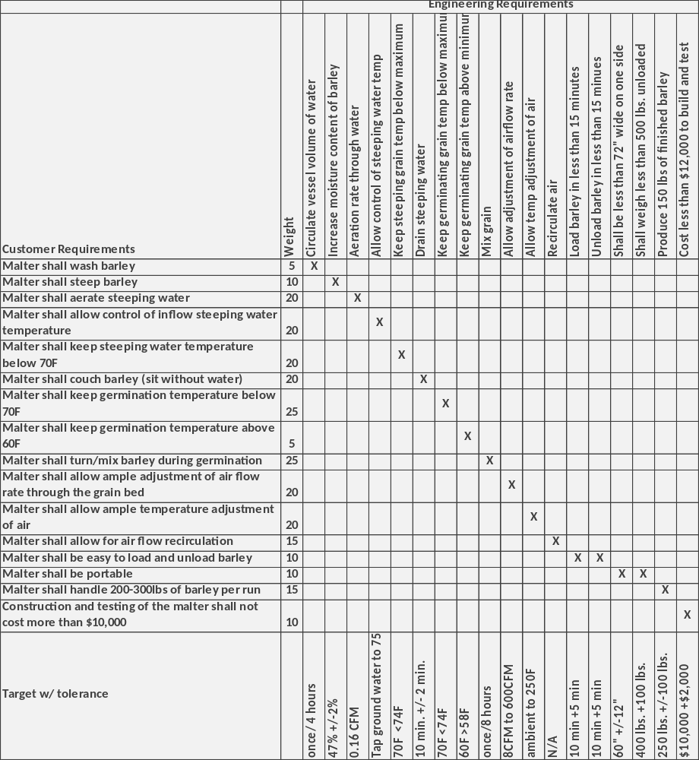

EXISTING DESIGNS, DEVICES, AND METHODS

System Level
People have been malting barley for at least the last 2000 years. The process has become more automated and precise as technology advances, but the fundamentals remain the same. It is possible to malt barley by hand, and indeed many home brewers do this regularly, though the results would likely not pass quality standards for large breweries. The current system that the Oregon State University Department of Food Science and Technology is using to malt barley is more sophisticated than most home brewers. They have been using several pieces of food processing equipment that get the job done, though the equipment was not designed for this particular use. Due to this, a system level discussion of the current process will be included here. Also included will be a pilot malter that is available for purchase, as well as the process followed by Great Western Malting, a large commercial malting company.

Design, Device, or Method #1
Currently the food science and technology department steep barley in a brewing kettle, germinate in a second vessel equipped with a ribbon mixer, and kiln in a dehydrator that they can reset to perform the necessary task. With relation to the customer requirements the current system falls short in several places. The tank used to steep lacks a simple way to remove the chaff and dirt that appears when the barley is washed. It does steep and couch the barley and allows for control of water temperature. It does not aerate the steeping barley, so there is a risk of suffocation of the barley. When it comes to germination, the barley first has to be moved to another vessel. While there, the germination temperature is uncontrolled, unless someone sprays or dumps water on it by hand. The ribbon mixer likely works well when preventing matting among the germinating grains though it may subject the grain to unnecessarily rough handling. After that, another move of the barley from one tool to the next is required. There the grain can be dried. The equipment currently being used for this allows for some control of air temperature and flow, but it does not meet all of the customer requirements. Lastly, due to the number of different pieces of equipment used in the process, it is not portable. This malting process also requires many hours of time and labor under the current method.

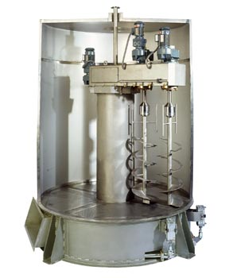
Design, Device, or Method #2
Schmidt-Seeger, a German manufacturer of malting equipment, currently produces a pilot sized malting system that is capable of handling 2800 lbs of grain per batch (www.schmidt-seeger.com). Here the steeping phase is separate from the germination and kilning phases. Although the batch size is 14 times larger than the design requirements for this project, it is still a useful system to look at. This unit allows for water temperature control during the steeping stage, as well as aeration control during both the steep and germination stages. The interesting thing about the pilot malter is the combination germination and kilning vessel (GKV). Rather than having a rectangular vessel it is circular. This allows the mixing augers to rotate around a shaft and move through the grain. This allows the grain to be mixed more evenly (due to the lack of corners) than in a rectangular system, giving a more uniform finished product. The largest problems with the customer requirements that this pilot malting unit has is that it produces much more malted barley than needed, it is not portable, and it likely exceeds the project budget.
Figure 1. Schmidt-Seeger pilot malting system

Design, Device, or Method #3
Great Western Malting Co. (GWM) is a large commercial malting company located in Vancouver, WA. They produce batches of malt that range from 140,000 to 300,000 pounds. This is over 800 times the batch size expected of the pilot malter to be designed but, once again, the same basic malting procedures can be found. Their focus is on solving different problems than this project though because they are making such large batches of malt. Uniformity is their goal. There are kilning beds, for example, that are so large that the air temperature from one end of the kilning bed to the other can be as much as ten degrees Fahrenheit difference. Similar discrepancies between the pilot malting unit sold by Schmidt-Seeger and our customer requirements show up with Great Western’s design. Theirs is a large factory which is neither portable nor within our budget. We also require a much smaller batch size. Furthermore, their process involves separate vessels for steeping.

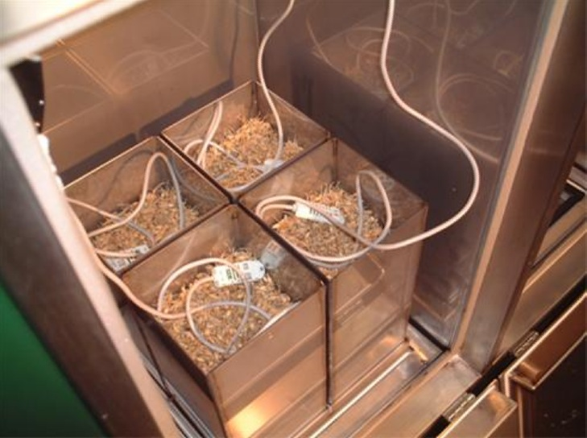
Design, Device, or Method #4
The final system level design considered was a micro malting system from Custom Laboratory Products, located in Scotland, which can handle a batch size of about 17 pounds. This system differed from the two previous in that the steeping and germination phases were separate from the kilning phase. The company stated that they think separating steeping from kilning is necessary because each process is so different and effectively carrying out each process in one vessel is not possible. The problem with the micro malting system is that it is an almost “too perfect” environment and doesn’t allow one to evaluate commercial quality malted barley. The system sample size is so small that issues often seen in a commercial factory are not present. One interesting solution in the system though is the way they humidify the air during the germination cycle. Rather than mist water in the air stream, which is how GWM does it, they bubble air through water. They also allow for control of the ratio of humid air to dry air to allow a progressive rootlet drying regime.
Figure 2. Custom Laboratory Products kiln

Component Level
Malting is a basic linear process in which barley seed is germinated and dried to produce malted barley. To fulfill the customer requirements the malter must perform four critical functions. The first is steeping, which entails wetting the dry barley seed. During this phase the moisture content of the barley is brought from 10% to 45%, at which point germination commences. The second function is airflow, which is important in both keeping the barley alive during the germination phase and drying it during the kilning phase. Third is mixing during the germination phase. Mixing helps keep the barley at a uniform moisture and temperature during the germination and kilning phase. It also makes the barley easy to unload by not allowing a root mat to form. Finally the kilning phase is important in that it stops the modification process, reduces the weight of the barley which makes it easier to unload, increases the storage life, and develops the flavor and color of the barley. If these essential tasks are completed successfully, the result will likely be a very high grade barley malt.

Component #1
Washing the barley is the first process in malting. It is crucial to eliminate the dirt and chaff or leftover husk. There are a number of methods to washing the barley.

Design, Device or Method #1
Schmidt-Seeger as well as GWM uses an overflow method on their steeping vessels. Water is constantly fed into the vessel. The overflow will spill into a drain pipe. All of the dirt and chaff floats to the top of the water and is carried out when the water overflows. This is a very effective method to continually wash a large batch of barley.

Design, Device or Method #2
Another method to wash the barley is a skimming method. Instead of having a continuous water flow into the steeping vessel, the tank is filled with water and then a device will skim off the top few inches of water that include all of the dirt and unwanted husks. This is a more cost efficient method but can be less likely to get all of the unwanted debris.

Design, Device or Method #3
A vacuum method can also remove dirt and chaff from the water. When all of the unwanted remains float to the top of the vessel, a vacuum is turned on which sucks up the top few inches of water. This seems like a good method to clean the barley but requires extra labor to clean out the vacuum.

Component #2
Steeping is the phase of malting in which the grain is hydrated from 10% moisture content to 45% moisture content. It is necessary to raise the moisture content of the grain to initiate germination. This is done by periods of wetting and couching or draining. The couching has been found to speed up the steeping process because it encourages vigorous respiration to take place within the grain. Respiration then lets the barley absorb more water the next time it is wetted.

Design, Device or Method #1
Flat bottom steeping is much as the name implies. Either a rectangular or circular vessel that has a flat bottom is repeatedly flooded and drained with water. These vessels can either have a lid or not. If they do have a lid they also require a CO2 removal system. If open topped, the ambient air dilutes the CO2 produced from respiration. These vessels can be aerated in a number of ways. Commonly, aeration nozzles are placed evenly about the floor of the vessel. As long as there is some sort of temperature control on the steeping water this would satisfy all of our customer requirements that involve steeping.

Design, Device or Method #2
Great Western Malting uses steeping vessels that are essentially large cylindrical tubes with funnel shaped bottoms. This allows them to load and unload the barley much more easily than a flat bottom steeping vessel by pumping the barley in and out through the funnel at the bottom. When dealing with the batch sizes that they are, this is a large concern. The aeration nozzles in the vessels they use are placed in concentric rings around the funnel. They can pump water into and out of the vessel as well as remove CO2. With the temperature control on the water inlet this design also satisfies all of the steeping customer requirements. The problem with this design is that it would likely require a separate steeping container, which would eliminate the portability of the device.

Design, Device or Method #3
Another steeping technique is to spray water over the grain with a freely draining bottom. Respiration is constant with this method but there are problems with uniform moisture gain. The barley on top of the bed will receive more water than the barley near the bottom. This could potentially be a large problem with commercial production because of the sheer size of the batches produced. With the batch sizes associated with this project it would be appropriate to assume that this problem would noticeably affect the quality of malt, if at all. Aeration would not be a problem with this design so those customer requirements would be satisfied. A simple control of the water temperature being sprayed on the grain would control the steep temperature, as well as potentially allowing for control of the germination phase temperature as well. Furthermore this method would not require a separate vessel, thus not affecting the potential for a portable device.

Design, Device or Method #4
Similar to plant nursery sprinkler heads there are misting heads also used in the plant nursery industry. The misting heads put out a very fine mist of water droplets, more like fog than rain. A free draining tray for the grain would also have to be used. A benefit to misting heads would be a very uniform distribution of water on top of the grain bed due to the mist mixing in the air space above the grain. A downside would be a low flow rate which would slow the vertical penetration of the water through the grain bed.

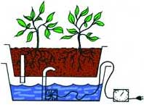
Design, Device or Method #5
Ebb and flow hydroponic systems flood a growing tray with water for a set amount of time and then lets the water drain. The water is pumped into the tray from a reservoir. Within the reservoir is a fill valve, where water from the pump enters the tray, and an overflow valve, where excess water flows back into the reservoir. Once the tray is filled with enough water to flow into the overflow valve it circulates the water. The overflow water splashes back into the reservoir, aerating it, and then is pumped back into the tray. This recirculation last until the set time has elapsed. The water then flows back out of the tray through the fill valve and pump. Some residual water is left in the tray, which is good for plants with roots, but may lead to rotting of barley. A benefit to this method is that chaff from the barley would float on top of the water and could be directed to the overflow valve.
Figure 3. Ebb & flow hydroponic system

Component #3
During the germination phase the barley begins to grow rootlets. If let to sit undisturbed, these rootlets will grow longer and longer and begin to mesh together. The grain will then be unable to dry properly which will produce inferior malt. Matting also traps the heat produced by the barley during respiration, which can be enough to kill some of the batch. To prevent this and to allow for even drying, the grain is turned, mixed, or tumbled approximately once every eight hours throughout the germination and kilning phases.

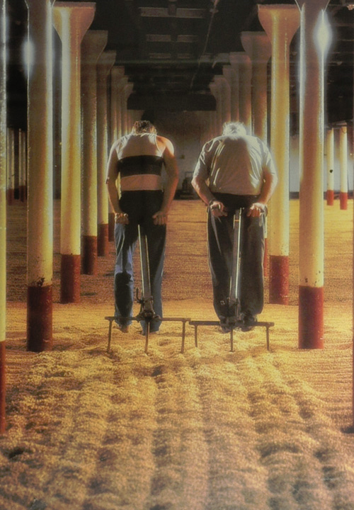
Design, Device or Method #1
Barley malt, until around the 1940’s was turned by hand. Around then, malters began using automatic devices for preventing matting. Hand turning does technically satisfy the customer requirements and would be the easiest to implement. The problem with that design is that the barley must be turned about once every eight hours. This means hiring someone, or having a student be responsible for turning the grain. It can be done with a shovel or other hand tool. This design is not ideal, due to the fact that the barley may need to be turned at inconvenient times of day and forgetting to perform this duty could ruin the batch. The advantage is that a human will be able to make sure that all the barley has been turned, and also be able to reach into corners and other areas an automated machine might not be able to.
Figure 4. Floor malting

Design, Device or Method #2
The germination beds at Great Western Malting, as well as the pilot malter sold by Schmidt-Seeger use augers to turn the barley. Both of these designs boast a series of augers in a line parallel, or tangential to the length of the bed (Figure 5). These lines of augers then move back and forth the length of the bed on tracks, or around the bed on a pivot, turning the barley every eight hours. Motion of the augers is very slow to limit damage inflicted on the grain by handling. This design has proven successful by industry and does satisfy the customer requirement regarding turning of the barley.
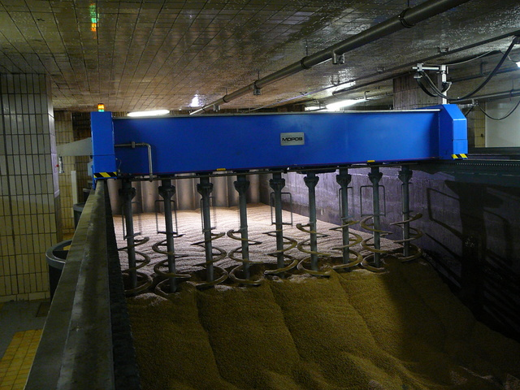
Figure 5. Augers turning barley in a commercial germination bed (www.mopos.com)

Design, Device or Method #3
Disc ploughs are used across the country and around the world to prepare fields for planting. Disc ploughs work by dragging a series of concaved discs through soil. They are arranged offset from one another to allow them to pickup and turn the soil they are being used on. A similar device might be used to turn the grain. This would satisfy the customer requirement. One potential problem with this is that the discs may be too rough with the grain, thus damaging it and adversely affecting the quality. Another issue would arise if the bed depth was too large for the disc ploughs to reach the bottom.

Component #4
Kilning is the phase in which the grain is dried and allowed to develop color and flavor. In combination with airflow the air is heated progressively to dry to the grain. The process occurs over a 24-48 hour period. The temperature is increased in steps over this period from around 120F to 180F.

Design, Device or Method #1
Dryers essentially perform the same task as the kilning phase of barley. Hot air is blasted through wet clothes to dry them out. This is accomplished by flowing air over an electric heating element. The heating element is made up of coils of nichrome wire, which has a high resistance. As the electricity flows through the nichrome wires they heat up. Due to the similarity of the task that a dryer element is built for, and our customer needs, implementing this device would likely not be very complicated.

Design, Device or Method #2
Household gas furnaces work by using a direct-heat heat exchanger. Gas is ignited by an electric heating element and then flows through the heat exchanger. Air then flows across the heat exchanger which increases the temperature of the air. If the air is re-circulated through the device, not as much gas needs to be used to heat the air, because it will retain some heat from the previous heating. This will save on the amount of gas needed and the time it takes to heat the air.

Design, Device or Method #3
The radiator in a car is often seen as a way to cool the engine, but it’s also a way to heat the air flowing over the radiator. The radiator is an indirect heat exchanger in which a fluid (water, oil, etc.) is heated and then cooled by air flowing over the channels of hot fluid. The fluid flows from the heat source (the engine) to the heat exchanger (radiator) and the heat is transferred from the fluid to the air. The fluid is then re-circulated throughout the engine.

Component #5
The malted barley has to be removed from the mini malter in order to be useful for brewing. This process will depend on the design of the vessel, but some methods will apply regardless of the shape.

Design, Device or Method #1
Similar to the turning of the malt, this process could be done by hand. One or two people with shovels could unload 200 to 300 pounds of malt, though this would be the most labor intensive way to perform the task. Unloading by hand would also take significantly longer than automatic methods. This does not satisfy the customer requirement of being easy to load and unload. On the other hand, it would not require any special designs, nor would it cost anything to implement. This method would also eliminate the chance of mechanical failure.

Design, Device or Method #2
At Great Western Malting they are producing batches of a size that makes unloading by hand unfeasible. Instead they have a system that lowers a beam into the grain on one end of the kilning bed. A winch is then attached to that beam that drags the beam from one end of the bed to the other. The grain is scraped off one layer at a time. With the amount of barley this project is designed for, it would only take one run of a similar method to empty our device of grain. This would meet the customer requirement of being easy to unload in that it requires little physical labor, and is not very technologically complicated.

Design, Device or Method #3
A third method of unloading the grain would be to design something similar to a dump truck. If one wall or section of a wall was capable of being lowered or opened, the bed could then be tipped up and the grain emptied. This satisfies the requirement of being easy to unload. This design would have more points of failure, but would also require the least amount of effort.

Designs considered

Design #1

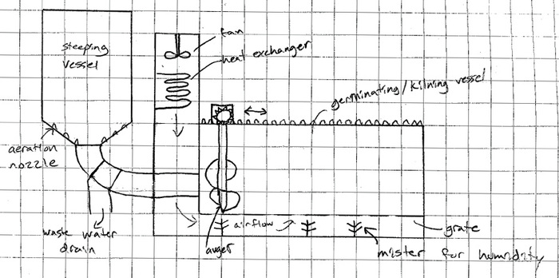
Figure 6. Proposed Design #1 – 2 Vessel Malter

One design to consider is having a malter that performs the steeping phase in a separate vessel. This vessel could be any shape or size, as long as it is large enough to handle the appropriate amount of barley. The barley would be allowed to steep and couch in this separate, waterproof section. Aeration nozzles would be required to keep the water full of oxygen to allow the barley to breathe during this first stage of the malting process. A system for removing CO2 buildup would need to be in place if the vessel were to have a lid. Due to the small batch size in this malter it would be just as acceptable to have an open steeping chamber. This would allow the CO2 to diffuse out of the vessel on its own. The barley could be washed in this separate vessel as well. An overflow drain near the top of the vessel will allow the dirt and chaff to be flushed out of the barley. Load Cells would be needed in the steeping vessel to measure the weight of the batch. This would allow the operators to track the moisture gain of the barley. When the grain had absorbed enough water to begin the germination phase it would be moved to the germination and kilning vessel (GKV). The simplest way to do this would be to have the steeping vessel above the GKV. It would be a simple matter to open a valve at the bottom of the first vessel and flush the grain down into the GKV. Augers that run along a track on the outside of the GKV would spread the grain evenly throughout bed. The same augers would also be responsible for turning/mixing the barley to prevent matting during germination and allow for even drying during kilning. Fans will pull air through the GKV. This air will allow for healthy respiration during germination. Using a heat exchanger, the same air can be heated to dry the grain during the kilning phase. A set of sprinklers or misters above the GKV will enable the vessel to cope with the heat produced during germination, as well as keep the air humid. Lastly, one section of the wall will open on hinges to allow for quick and easy unloading of the finished malt.

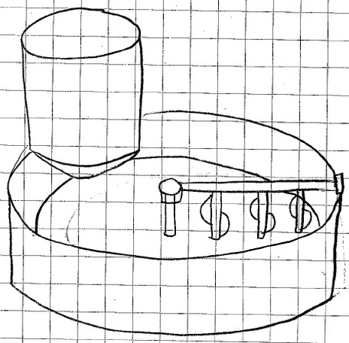
Pros
Do not have to make one vessel compatible with all three processes.
Simple design
Industry standard

Cons
More material required (expensive)
Larger, less portable
Requires moving the grain from one vessel to another

Figure 7. Proposed Design #1 – 2 Vessel Malter
The two vessel malter could also have a cylindrical second vessel.

Design #2
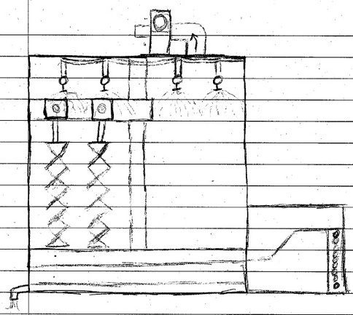
Figure 8. Proposed Design #2 – Cylindrical One Vessel Malter side view
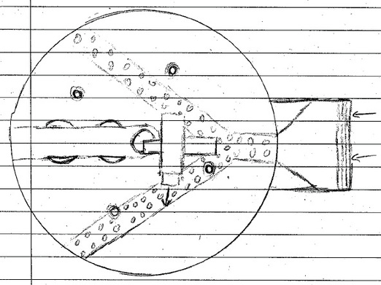
Figure 8. Proposed Design #2 – Cylindrical One Vessel Malter top view
The second design we looked at was a circular type, which is similar to the Schmidt-Seeger pilot malting system described in section 2.1.2. The main difference is the ability to also kiln in our proposed design. Kilning is accomplished by using a heat exchanger in which hot water under high pressure flows through to heat incoming air. The heat exchanger is seen in the above pictures to the right of the circular malting chamber. After the air passes through the heat exchanger it then flows into two 4" diameter pipes arranged in a Y formation. The pipes are drilled with many holes to allow a more even distribution of airflow through the grain. Above the pipes is a false bottom with a mesh size large enough to allow adequate airflow, yet small enough to keep barley from passing through. The hot air flows through the barley and is finally sucked out the top of the malter by a high pressure blower. This same air flow path is used during germination, but without the heat exchanger on.
Steeping is accomplished by 4+ sprinklers hanging from the top of the malter. As designed, the malter would be free draining and so would not immerse the barley in water, but would be wetted by the sprinklers. The sprinklers would also serve to keep the temperatures down and the humidity high during germination.
Finally mixing is accomplished by two augers which rotate around a shaft in the center of the malter. This circular design would allow for the barley to travel around the chamber. If the airflow and water penetration through the grain bed were not uniform this travel would help mix the grain to attain a uniform product. Also the lack of corners would prevent grain from getting stuck and receiving too much/too little airflow or water.
Pros
Creates a very uniform malted barley
Easy to clean because of lack of corners
Sprinklers a cheap, yet foolproof way to keep germinating grain cool and humid
Cons
Circular design may be expensive to manufacture
Malter would be larger and less portable
Lack of immersion during steeping wouldn't allow even water adsorption

Design #3
Figure 9. Proposed Design #3 – Rectangular One Vessel Malter side and top view
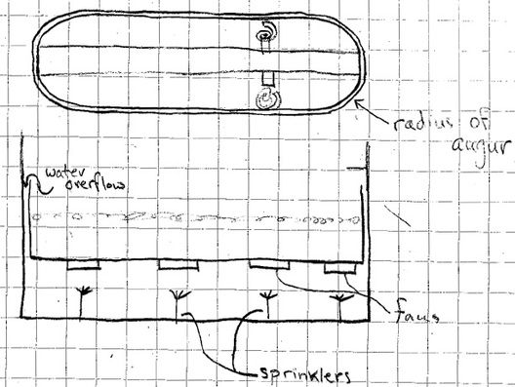

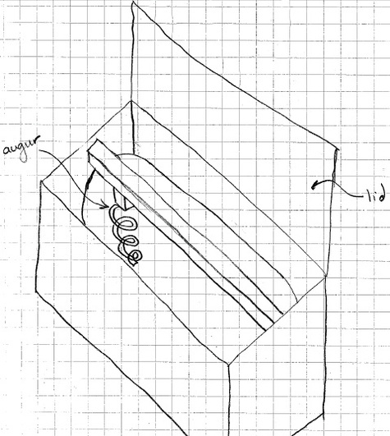
Figure 10. Proposed Design #2 – Rectangular One Vessel Malter isometric view

The rectangular shaped single-chambered malter is another design that was considered. This malter has been designed to have rounded corners to allow the augurs to mix all of the barley. The round edges will have the same radius as the augurs. The pictures above show a rough sketch of the rectangular malter. The chamber that contains the barley will be inside an outer casing. The outer casing will house the sprinklers, fans, and overflow system. Sprinklers have been placed under the barley chamber to humidify the air. There are also fans at the bottom of the barley chamber that will aerate the barley during the germination and kilning phases. The overflow system will wash the barley. We will fill up the barley chamber with water during the steeping phase and when the chamber is full the water will flow over the edges. The overflow water will be directed to the waste drain. There will be two circular augurs that will mix the barley during germination and kilning. The augurs will travel linearly throughout the chamber.

Pros
Cheaper and easier to manufacture
Overflow system will result in consistent water absorption
Not as bulky

Cons
Airflow will not be as efficient
May be hard to control the cooling during germination

design selected

Rationale for Design Selection
In chapter 3 we examined three distinctly different design solutions: a two vessel system, a circular single chamber system, and a rectangular single vessel system. The decision has been made to pursue the circular single chamber design because it will produce a more uniform and higher quality product. With the circular design we also chose to include revisions and additions of certain components. The ventilation of the circular chamber will be similar to what is already in the design. The main difference will be the addition of a sealing mechanism between the circular chamber and heat exchanger due to the use of immersion steeping techniques. The seal will need to be water tight so that when the malting chamber is completely filled with water none will leak into the heat exchanger chamber. Also, because we chose to immerse the grain in water, aeration nozzles will be added to the bottom of the malting chamber for use during steeping. The aeration nozzles are necessary to keep the grain alive during the steep phase. The reason for using the immersion technique to steep the barley is to produce the highest quality malt. If we did a free drain technique the barley would not have as consistent water content throughout the barley. We have also decided to use sprinklers to fill the barley chamber. The reason for this is that we can also use the sprinklers during the germination phase to cool the barley. We do not see a reason to add an extra water pipe just to fill the tank. After the steeping phase we will open a drain valve that will allow all of the steeping water to flow out of the barley chamber. We have also decided to use an overflow system to wash the barley. Instead of including another phase to wash the barley, we have decided to wash the barley during the steeping phase. We will continually pump water into the barley chamber. In the side of the chamber we will have a hole with a pipe leading to a drain. When the water reaches the level of the hole in the chamber the top layer of water, along with the dirt and chaff floating in it, will flow out of the chamber to the drain. We decided to keep the blower for aeration because it is ideally suited for the application. The grain bed will cause the airflow to back up during germination/kilning and so a fan that can operate at a high pressure is needed. Blowers can provide the power to move a high volume of air at a high pressure. To heat this air for the kilning process a steam heat exchanger will be used. There is already a suitable heat exchanger in the pilot brewery in that is available for use.

BIBLIOGRAPHY

"Our Home: Distillery - Virtual Distillery Tour | Bowmore Islay Single Malt Scotch Whisky." Home | Bowmore Islay Single Malt Scotch Whisky. Web. 18 Oct. 2010. <http://www.bowmore.co.uk/our-home/distillery-virtual-distillery-tour?guide=eddie&location=malt-barn&play_all=false>.

“Malt Plants.” MOPOS. Web. 19 Oct. 2010. <http://www.mopos.com/production-programme/malt_plants.htm?lang=en>

"Schmidt-Seeger Malt Processing Technology Malting Technology." Schmidt-Seeger GmbH. Web. 18 Oct. 2010. <http://www.schmidt-seeger.com/en/products_processing1.html>.

