Design Review

OSU Mini Malter

11-19-2010

**Project Description**

Oregon beer and spirits are made from malts produced from barley not grown in Oregon. The reason Oregon barley is not in Oregon products is a lack of data on the suitability of Oregon barley for Oregon- produced malts. Currently, research samples are malted at 350 grams each and the minimum commercial run is 350,000 lbs. There is no opportunity for producing malts suitable for pilot brewing. The OSU Pilot brewery, located in the Department of Food Science and Technology, is the perfect facility for testing, developing, and demonstrating the suitability of Oregon barley for Oregon malts. The brewery requires ~ 200 lbs of barley to produce malt for a 100 gallon brew. Mechanical Engineering students will design, build, and develop a pilot malting unit - a “flex box” for steeping, germinating, and kilning in a single unit. The flex box will remove the malting bottleneck and get Oregon grain flowing to Oregon glasses. A project budget of $10,000 will be provided.

**Customer Requirements**

**Malter shall wash barley (Weight 5 pts.)**  
Washing the barley is essential to eliminate any excess dust and dirt on the barley. It is something the customer would like but is not on the top of their priority list. The weighting reflects this.  
  
**Malter shall steep barley (Weight 10 pts.)**  
Steeping is the first main process in malting barley. Steeping is important to increase the moisture content of the barley so that it can begin to germinate. Steeping is conducted by immersing the grain in water for a period of time and then draining the water off for a period of time. This cycle is repeated until the moisture content of the barley is around 45%. An example steeping regime is below, but these times are adjustable.

8 hour immersion followed by a 6 hour couch (drain). Barley moisture percentage after cycle: 33%-35%  
6 hour immersion followed by a 10 hour couch. Barley moisture percentage after cycle: 38-41%  
4 hour immersion followed by a 2 hour final couch. Barley moisture percentage after cycle: 44-47%  
  
**Malter shall aerate steeping water (Weight 20 pts.)**  
Aerating the steeping water is important to dilute excess carbon dioxide produced by respiration of the barley. The barley grains can also suffocate if the water is not aerated.

**Malter shall allow control of inflow water temperature (Weight 20 pts.)**  
By changing the temperature of the inflow steeping water the time spent in the steeping phase can be shortened or lengthened. This is something that large malters cannot do, and so the sponsor is interested in seeing the effects of temperature on steeping times.  
  
**Malter shall keep steeping water temperature below 73F (Weight 20 pts.)**  
Keeping the steeping water below 73F is essential. If the barley reaches a temperature of 75F it will die. If the barley is killed by high temperatures the grain would have to be thrown away and the process restarted. The weighting reflects the importance of this requirement.  
  
**Malter shall couch barley (sit without water) (Weight 20 pts.)**  
Couching barley is important so the barley absorbs the moisture in its surroundings. This is where the barley absorbs the most moisture and so this is weighted more heavily.  
  
**Malter shall keep germination temperature below 73F (Weight 25 pts.)**  
The germination temperature should also not rise above 73F. Just like during steeping if the barley gets too hot it will die. Germination is when barley tends to heat up so this is an important requirement.  
  
**Malter shall keep germination temperature above 58F (Weight 5 pts.)**  
Keeping the germination temperature above 58F is needed so the barley can effectively germinate. If the air is too cold then the barley will not germinate. The malter will operate in room temperature surroundings and so low temperatures aren't likely.   
  
**Malter shall turn/mix barley during germination (Weight 25 pts.)**  
Mixing/turning the barley during germination allows for even moisture and temperature distribution. Turning also prevents the germinating barley from forming a thick mat of roots. The barley should be turned every eight hours after the initial 24 hours of germination. This first period of rest is to allow the barley to strengthen after steeping to prevent damage to the grain. Germination can take anywhere from one to four days. Mixing/turning is a critical requirement for producing a consistent malted barley and is weighted accordingly.  
  
**Malter shall allow ample adjustment of air flow rate through the grain bed (Weight 20 pts.)**  
Being able to vary the air flow rate is important as the germination phase and kilning phase require different air flow rates. During kilning it's also important to adjust air flow rate so that different malted barley types can be produced.  
  
**Malter shall allow ample temperature adjustment of air (Weight 20 pts.)**  
When kilning the malted barley it's important to slowly ramp up the air temperature. This stops the enzymes within the barley from activating. Also, higher temperatures can be used to produce different malted barley types. Pale malts are kilned for a longer time and lower temperatures, approximately 24 hours at 100F to 120F, and darker malts are kilned at higher temperature for shorter times.  
  
**Malter shall allow for air flow recirculation (Weight 15 pts.)**  
Air flow circulation will make the kilning phase more efficient in producing highly kilned (darker) malts.   
  
**Malter shall be easy to load and unload barley (Weight 10 pts.)**  
The customer does not want loading and unloading to be hard or take a long time. They also do not want to put any unnecessary stress on their body.  
  
**Malter shall be portable (Weight 10 pts.)**  
The customer would like the malter to be somewhat portable so it can be used in classroom demonstrations, as well as taking it to other places on campus. The malter should be easily transported by one or two people.  
  
**Malter shall produce at least 150 lbs of malt per run (Weight 15 pts.)**  
The customer would like the malter to have a minimum production capacity of 150 pounds. This is to allow enough malted barley to be produced to brew a batch of beer in the pilot brewery.  
  
**Construction and testing of the malter shall not cost more than $12,000 (Weight 10 pts.)**  
We are given a $12,000 budget and it is important that we work within this limit.

**House of Quality**



**Engineering Requirements and Tolerances**

***Refresh vessel volume of water***  
Replenishing of the water during the steeping phase is important to clean the grain and keep fresh water accessible to the grain. The target value is to circulate the entire volume once every 4 hours with a tolerance of +/- 0.5 hours.  
  
***Increase moisture content of barley***  
The purpose of steeping is to increase the moisture content of the barley grain. It should go from around 10% up to around 45%. The target value is 47% with a tolerance of +/- 2%.  
  
***Aeration rate through water***  
During immersion steeping the water must be aerated or else the grain will suffocate and die. After talking with industry contacts we decided on an aeration rate of 0.5CFM with a tolerance of > 0.2 CFM.  
  
***Allow control of steeping water temperature***  
The customer would like to control the temperature of the water coming into the malting chamber. The range is from the ground water temperature up to 75F.  
  
***Keep steeping grain temperature below maximum***  
If barley reaches a temperature of 75F during the malting process it will die. We are targeting to keep the steeping grain at 70F or below, but have a tolerance of <73F.  
  
***Drain steeping water***  
During the steeping phase the water must be drained to allow the barley to couch. To allow couching to begin quickly we are target a drain time of 10 minutes with a tolerance of +/- two minutes.  
  
***Keep germinating grain temperature below maximum***  
If barley reaches a temperature of 75F during the malting process it will die. During the germination process we are targeting to keep the grain at or below 70F, with a tolerance of <73F.  
  
***Keep germinating grain temperature above minimum***  
If barley is too cold, around 55F, during germination it will germinate slowly and inconsistently. During germination we are targeting to keep the grain at or above 60F with a tolerance of >58F.  
  
***Mix grain***  
Mixing the barley is essential in producing a uniform product. Great western malting mixes their barley once every 8 hours and we thought that would be a sufficient target. We assigned a tolerance of +/- 0.5 hours.

***Allow adjustment of airflow rate***  
The airflow rate needed through the grain bed varies depending on the amount of grain and the phase of malting which the grain is in. At great western malting the airflow rate is 20 CFM per 100 lbs. of barley during germination which means for a 150 pound load the flow rate would be ~30 CFM. During kilning the airflow rate is 137 CFM per 100 lbs. of barley, so with a load of 350 lbs. of barley the maximum flow rate would be ~478 CFM. To cover these values the target range is 25 CFM – 500 CFM.  
  
***Allow temperature adjustment of air***  
The temperature of the air flowing through the grain bed is important during the germination and kilning phase. During germination the temperature should be that of ambient air. During kilning it should be adjustable from 120F up to 250F to allow step increases in temperature. This allows for the malt to dry more consistently and also allows the customer to create different degrees of browning (which create flavor, aroma, and color). To make sure that 250F is attainable we are designing for a range of ambient room temperature up to 260F.  
  
***Recirculate air***  
To allow the customer to create highly browned malt, while keeping the malter efficient it should be able to recirculate the hot air during the kilning phase. We are targeting 50% recirculation with a tolerance of >45%.  
  
***Load barley in less than 15 minutes***  
The malter should be quick and easy to load so that the malting process can begin promptly. We are targeting a load time of 10 minutes with a tolerance of <15 minutes.  
  
***Unload barley in less than 15 minutes***  
The malter should be quick and easy to unload so that the malter can be cleaned an set up for the next malting cycle. We are targeting an unload time of 10 minutes with a tolerance of <15 minutes.  
  
***Shall be less than 72" wide on one side***  
The malter should be able to fit through a standard double wide door to allow transportation to different areas of the OSU campus. We are targeting a width of 40" with a tolerance of <72".  
  
***Malter shall weigh less than 700 lbs. unloaded***  
To allow the malter to be easily transported by 1-2 people the malter should weigh less than 700 lbs. unloaded. We are targeting a unloaded weight of 600 lbs. with a tolerance of <700 lbs.  
  
***Process 150 lbs of barely***  
The customer needs the malter to process a minimum of 150 lbs. of barley in one batch so it can be used to brew a batch on the OSU pilot brewing system. We are targeting 250 lbs. of finished malt per batch with a tolerance of +/-100 lbs.  
  
***Cost less than $12,000 to build and test***  
The customer would like the project to cost less than $10,000 to build, but told us that additional money is available if needed. Therefore the project must cost less than $12,000. We are targeting the project to cost less than $10,000 with a tolerance of <$12,000.

**Process Block Diagram**

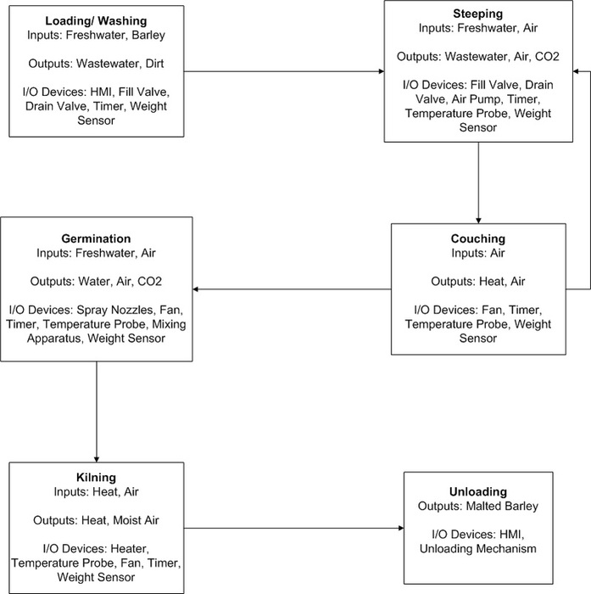

**System Component Interaction Block Diagram**



**I/O Devices**

Electronics Needed:

* At least three temperature sensors

Thermocouples that are compatible with National Instruments CompactDAQ Assistant so that the data can be monitored and the malter controlled with LabVIEW

* Weight sensor

1 to 4 Load Cells placed underneath the malter. These will also be run with LabVIEW

* Humidity sensor

1 Humidity sensor placed near the air inlet to the barley chamber. Also connected to the CompactDAQ Assistant

* Switch to turn auger blade rotation on/off

|  |  |  |  |  |  |  |  |  |
| --- | --- | --- | --- | --- | --- | --- | --- | --- |
| |  | | --- | | [http://www.mcmaster.com/catalog/116/gfx/small/6142kp2s.gif](javascript:chgimg('EPOAC');) | | Face Mount | | [http://www.mcmaster.com/catalog/116/gfx/small/6142kl2s.gif](javascript:chgimg('E4OAC');) | [http://www.mcmaster.com/catalog/116/gfx/small/whites.gif](javascript:chgimg('EGPAC');) | |  | | --- | | [http://www.mcmaster.com/catalog/116/gfx/small/6142kp1s.gif](javascript:chgimg('ETPAC');) | | Base Mount | | [http://www.mcmaster.com/catalog/116/gfx/small/6142kl1s.gif](javascript:chgimg('ECAAE');) |
| The following are general guidelines for choosing rotations per minute (rpm): For valve operation, use a 1-10 rpm motor. For stirring and mixing applications, use a 20-100 rpm motor. For fan operation, use a motor with an rpm greater than 100. | | | | |
| The simple, shaded-pole design (no start switch or capacitor) of these gearmotors is perfect for your light duty, direct-drive applications. Each gearmotor has a motor and fan matched with a geared speed reducer to lessen speed while increasing torque. Using a gearmotor can eliminate the need for belts, chains, and other speed reducers.     Gearmotors are rated for continuous duty and have an open fan, sleeve bearings, steel gears, Class B insulation rated to 266°  F, and lead wires for electrical connection. They also have a clockwise rotation (when facing the shaft end) and are not reversible. Shaft diameter is 0.312" (0.281" across flat); shaft length is 1". Housing is steel. UL listed and CSA certified.     **Face-mount motors** have eight mounting holes on the face that are tapped for 8-32 screws. **Base-mount motors** have four mounting holes on the face that are tapped for 10-32 screws, plus two 0.19" dia. untapped holes on the base. | | | | |

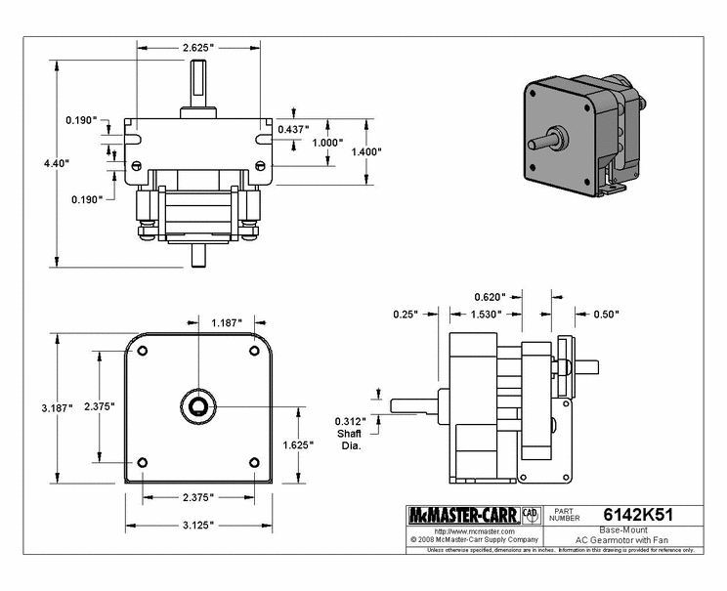

* Switch to turn auger arm rotation on/off
* Switch to turn exhaust blower on/off and control speed
* Switch to turn heat exchanger on/off and control output heat

These last four switches will all be Voltage Ascending Relay Modules that allow us to ramp up the voltage signal from the DAQ assistant to the voltage needed by the various devices to operate. The auger blade and arm will rotate at only one set speed so those need to be turned on and off at the appropriate times. The blower

* Electronic valve to turn sprinklers on/off

Solenoids controlled by LabVIEW will open and close the water valves

* Controller to operate the entire cycle

CompactDAQ Assistant from National Instruments.

Top of Form

|  |  |  |  |  |  |
| --- | --- | --- | --- | --- | --- |
| NI cDAQ-9174 [NI cDAQ-9174](http://ohm.ni.com/advisors/compactdaq/pages/common/guided/summary.xhtml?conversationContext=3) | Voltage - NI 9201 with Screw Terminals [NI 9201 with Screw Terminals](http://ohm.ni.com/advisors/compactdaq/pages/common/guided/summary.xhtml?conversationContext=3) | Temperature - NI 9211 [NI 9211](http://ohm.ni.com/advisors/compactdaq/pages/common/guided/summary.xhtml?conversationContext=3) | Voltage - NI 9263 [NI 9263](http://ohm.ni.com/advisors/compactdaq/pages/common/guided/summary.xhtml?conversationContext=3) | Chassis - NI cDAQ-9174 http://ohm.ni.com/images/advisor/cdaq/placement/modules/cdaq_filler.jpg | NI cDAQ-9174 [NI cDAQ-9174](http://ohm.ni.com/advisors/compactdaq/pages/common/guided/summary.xhtml?conversationContext=3) |



Bottom of Form

Configuration ID

CD2064913

Top of Form

**[Voltage](http://ohm.ni.com/advisors/compactdaq/pages/common/guided/summary.xhtml?conversationContext=3)**

|  | **Part Number** | **Description** | **Quantity** | **Price** |
| --- | --- | --- | --- | --- |
|  | 779013-01 | NI 9201 8 ch, 12-bit, +/-10VDC, 500 kS/s, AI Module | 1 | .$ 379 |
|  | 779017-01 | NI 9932 Backshell with 10-pos connector block (qty 1) | 1 | .$ 29 |
|  | 779012-01 | NI 9263 4 ch,16-bit, +/-10 V, 100 kS/s/Ch, AO Module | 1 | .$ 379 |
|  | 779017-01 | NI 9932 Backshell with 10-pos connector block (qty 1) | 1 | .$ 29 |
|  | **Subtotal:   $ 816** | | | |

**[Temperature](http://ohm.ni.com/advisors/compactdaq/pages/common/guided/summary.xhtml?conversationContext=3)**

|  | **Part Number** | **Description** | **Quantity** | **Price** |
| --- | --- | --- | --- | --- |
|  | 779001-01 | NI 9211 4-Ch ±80 mV, 14 S/s, 24-Bit TC and Diff AI | 1 | .$ 329 |
|  | 779017-01 | NI 9932 Backshell with 10-pos connector block (qty 1) | 1 | .$ 29 |
|  | **Subtotal:   $ 358** | | | |

**[Chassis](http://ohm.ni.com/advisors/compactdaq/pages/common/guided/summary.xhtml?conversationContext=3)**

|  | **Part Number** | **Description** | **Quantity** | **Price** |
| --- | --- | --- | --- | --- |
|  | 781157-01 | cDAQ-9174, CompactDAQ chassis (4 slot USB) | 1 | .$ 699 |
|  | **Subtotal:   $ 699** | | | |

**[System Accessories](http://ohm.ni.com/advisors/compactdaq/pages/common/guided/summary.xhtml?conversationContext=3)**

|  | **Part Number** | **Description** | **Quantity** | **Price** |
| --- | --- | --- | --- | --- |
|  | 763000-01 | Power Cord, AC, U.S., 120 VAC | 1 | .$ 9 |
|  | 780315-01 | Rugged Carrying Case for Portable Instrumentation | 1 | .$ 159 |
|  | 779473-01 | NI 9901 Desktop Mounting Kit | 1 | .$ 49 |
|  | **Subtotal:   $ 217** | | | |

**[Software](http://ohm.ni.com/advisors/compactdaq/pages/common/guided/summary.xhtml?conversationContext=3)**

|  | | **Part Number** | **Description** | | **Quantity** | **Price** |
| --- | --- | --- | --- | --- | --- | --- |
|  | | 776670-35 | LabVIEW Full Development System, Windows, Include 1 Year SSP | | 1 | .$ 2,599 |
| **Total Price:  $ 4,689** | | |

**Possible Changes to Design to reduce weight/height/cost**

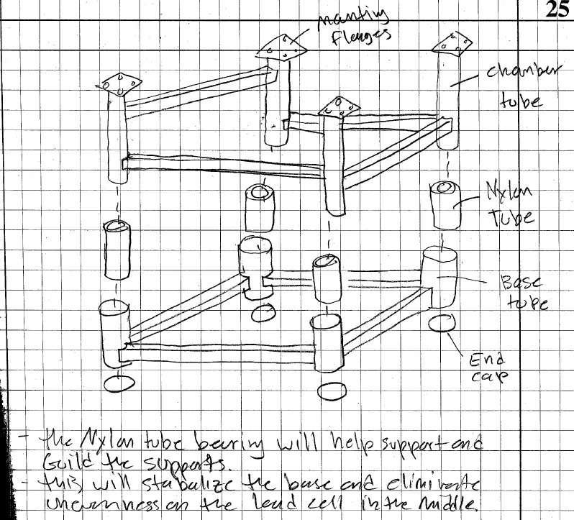

Proposed method of using one load cell and slides on the legs of the machine to determine the weight and thus the moisture content of the barley rather than with three or four load cells.

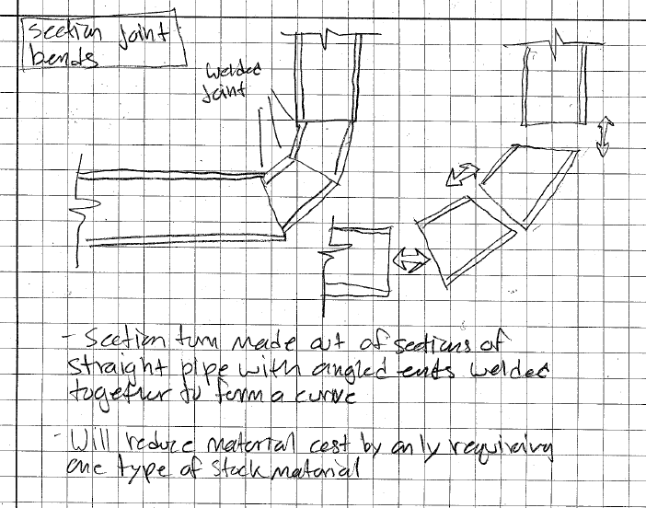

Since steel pipe bends are often very expensive it is cheaper to cut straight sections of tube and weld them together to create the bend needed.

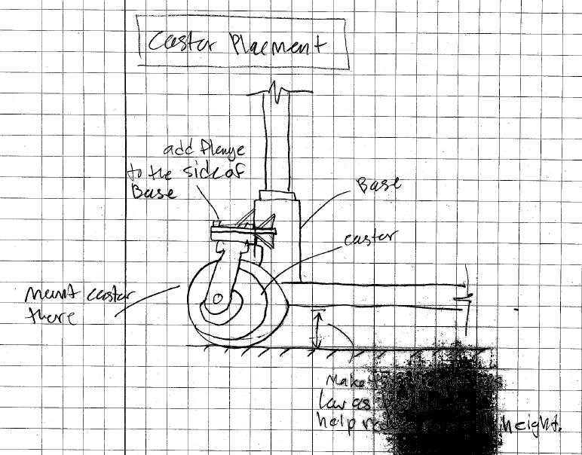

The design is getting rather tall as is. This method would lower the height of the malter almost the entire caster height.

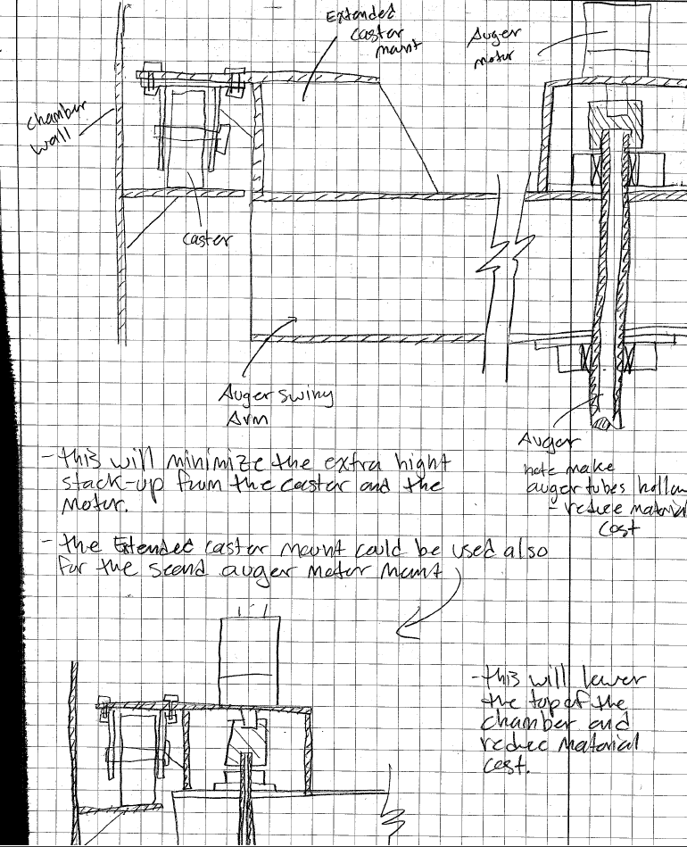

These are two additional ways to reduce the overall height of the malter as well as reduce the amount of material needed for the auger support arm. Both of which reduce cost of materials.

**Current Design Images**

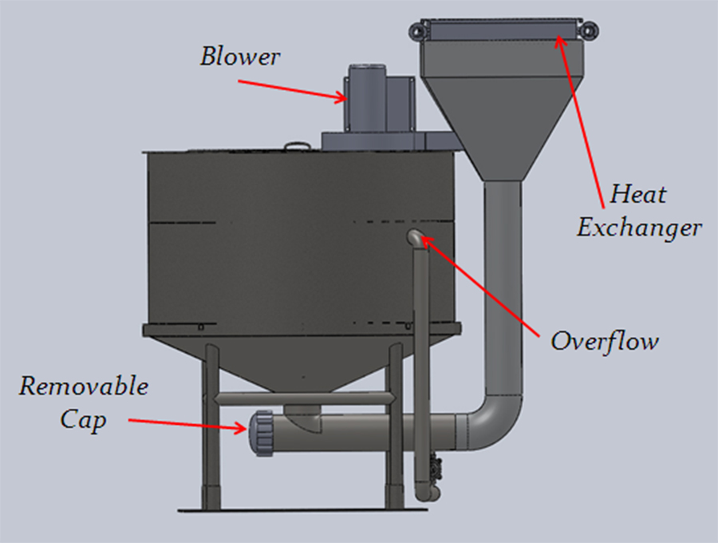

This is a back view that shows the blower which will pull air through the grain bed during germination and kilning. The air will be pulled through the heat exchanger, down through the piping, up through the diffuser and then through the grain. The removable cap at the bottom of the device will allow for easy cleaning of the air inlet, should any rootlets accumulate there.

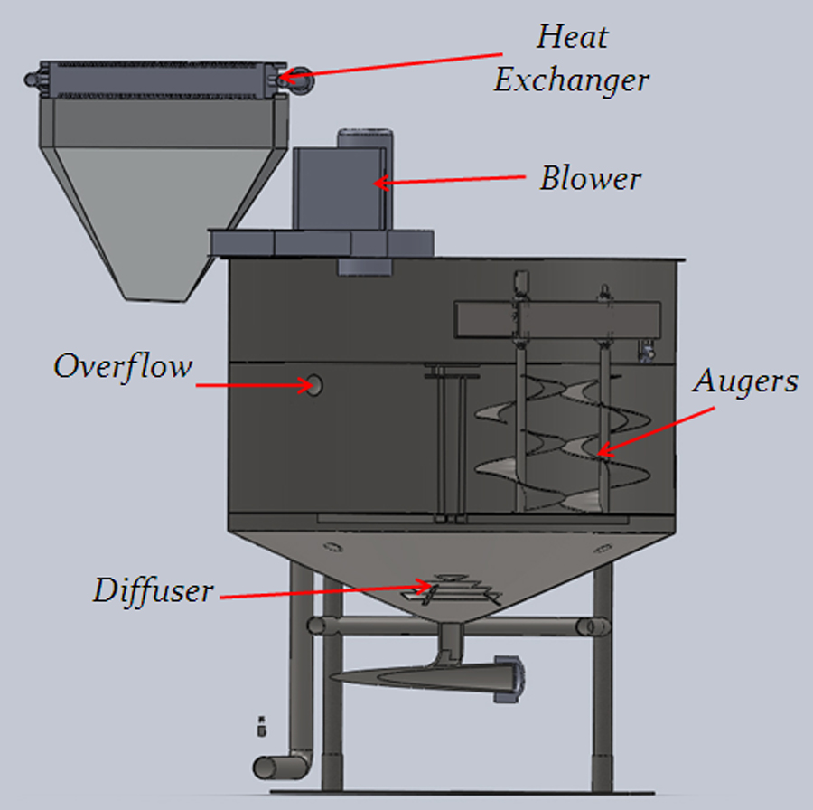

This is a cross section showing the diffuser and overflow more clearly. The overflow is to allow chaff and dirt to runoff during the washing stage, as well as allowing fresh water to be continuously run during the steeping stages. You can also see the diffuser more clearly, as well as a view of the augers.

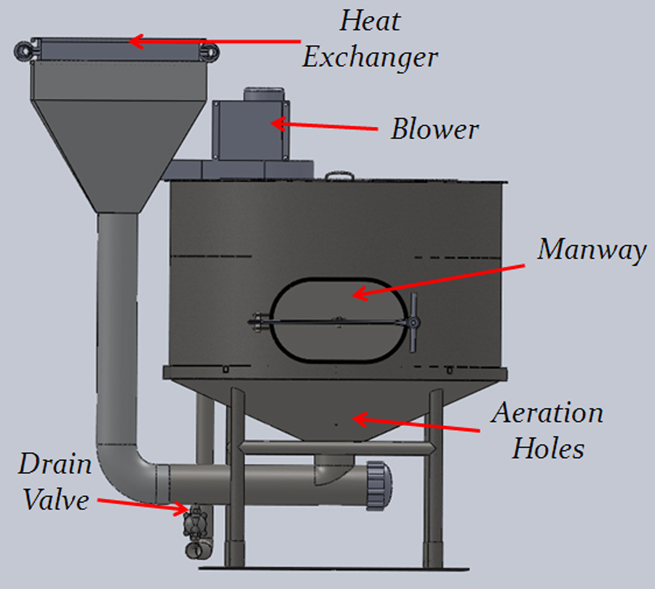

This view shows the manway that will allow for easy unloading of the barley. The aeration holes are also showed. These will be hooked up to compressed air. When engaged this will allow the barley to breathe during the steeping and germination stages.

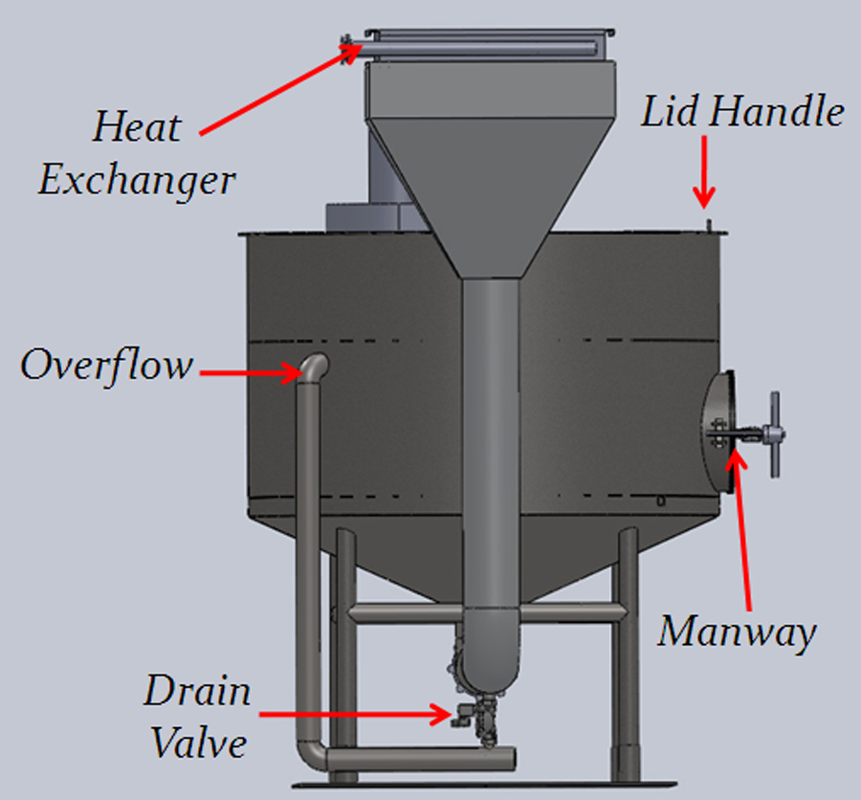

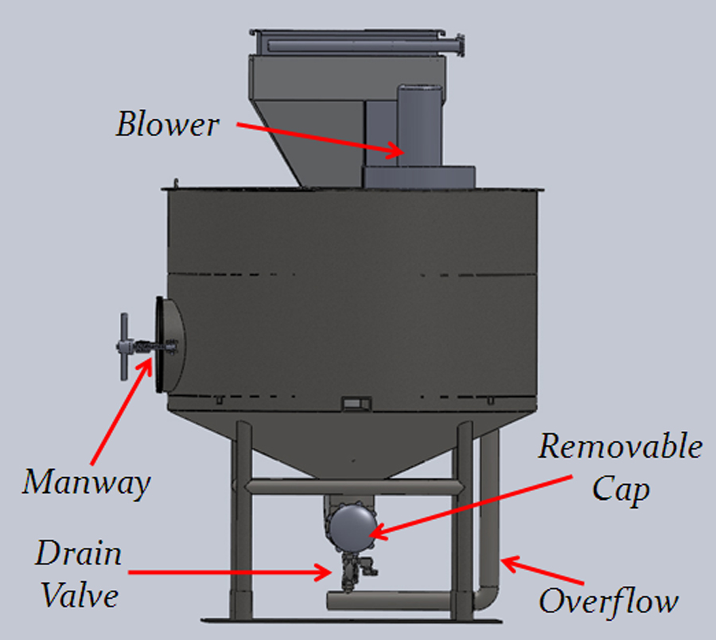

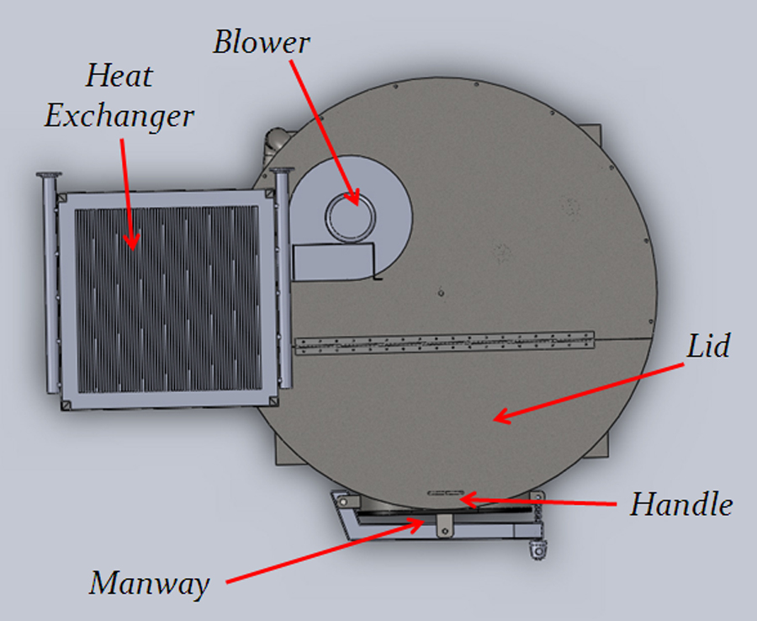

Here you can see how the lid will work. One section can be easily opened which will make loading the barley a snap, as well as allow for maintenance, should it be needed.

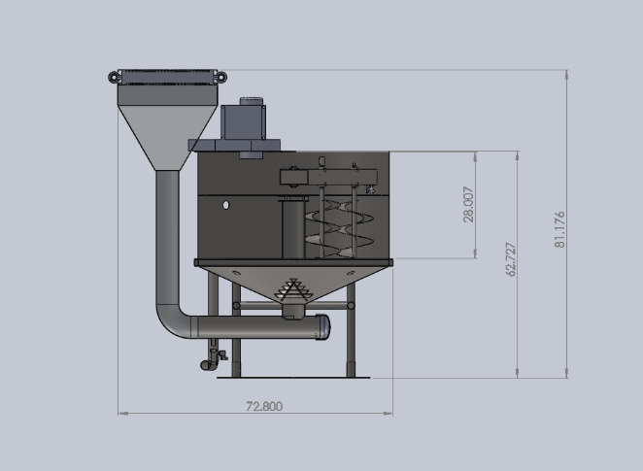

Side view showing overall height and length dimensions. Dimensions are in inches.

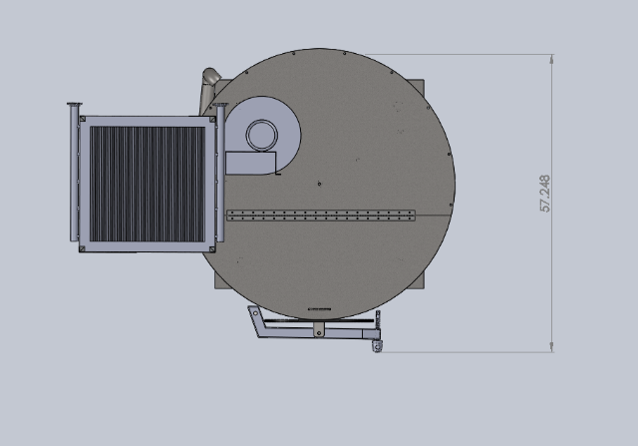

Top view showing overall width dimension.

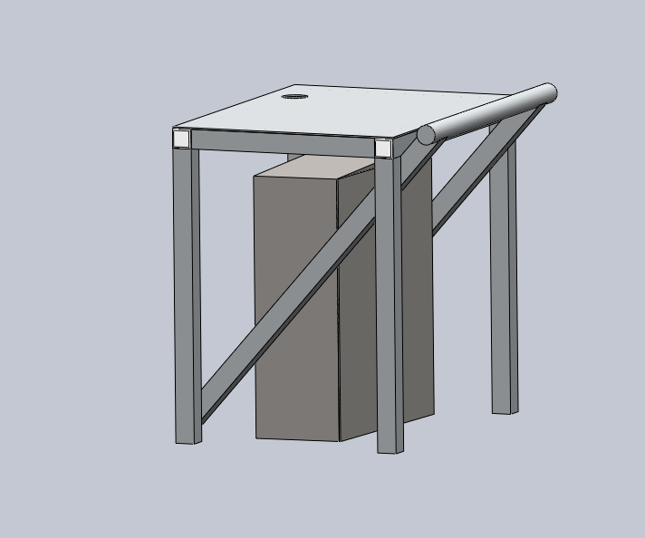

This Table will be welded to the base plate or cart surface that the malter is mounted on. The handle will help will moving the unit and the table will allow a pc, monitor, keyboard, and mouse to sit on. The electrical box will hold the compact daq, power sources, and switching modules.

**Next Steps**

Update model with changes to reduce weight, height, and material. Add in motors, motor mounts, electrical components, wiring, and tubing.

Place sensors

Update load cell configuration

Place sprinklers

Model and place solenoids and valves.

Reconfigure exhaust air recycling to meet the CR’s and ER’s associated with it.

Add in lid supports for the motor and blower

**Potential LabVIEW HMI interfaces**





**Comments**